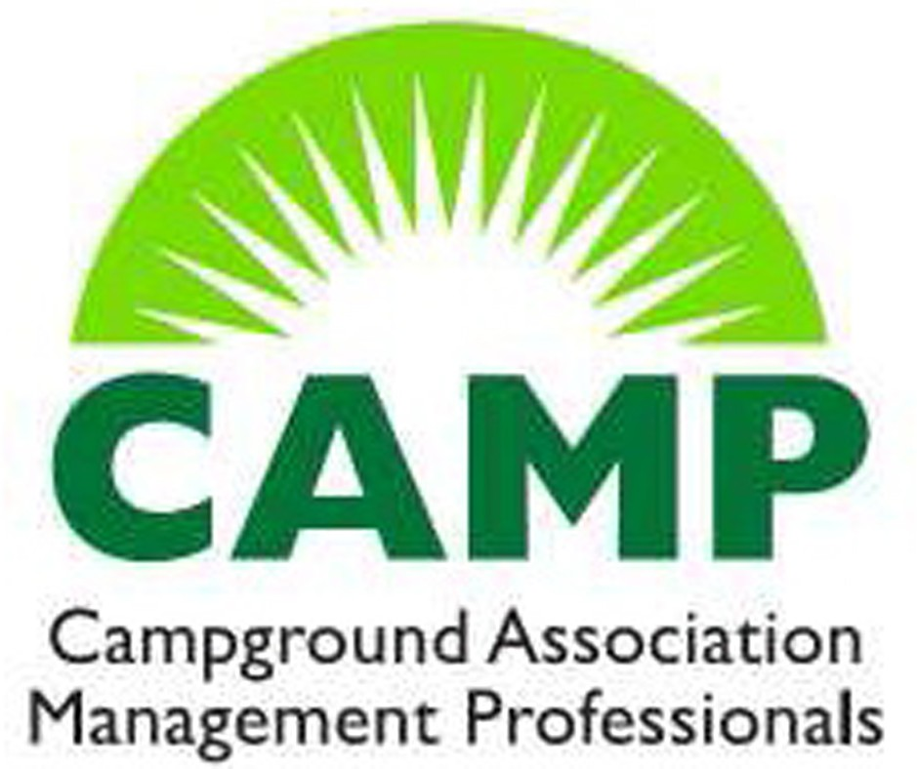
CAMP MEETING REGISTRATION FORM

SPRING CAMP: Washington DC
Mayflower Hotel
June 5, 2025

Name______________________________________________________________________

Association_________________________________________________________________

Address____________________________________________________________________

City State Zip_______________

Phone Email__________________________________
**PLEASE COMPLETE A REGISTRATION FORM FOR EACH ATTENDEE**

Cost for each individual (Due by May 30th) $50.00
*We are currently working on the Agenda and will forward as soon as possible.

Make checks payable to CAMP AND MAIL TO:
LARVC
Lisa Thibodaux
PO Box 4092
Baton Rouge, LA 70821

Questions
Call: Lisa 225-235-2166 or Email: lisa@campinglouisiana.com

